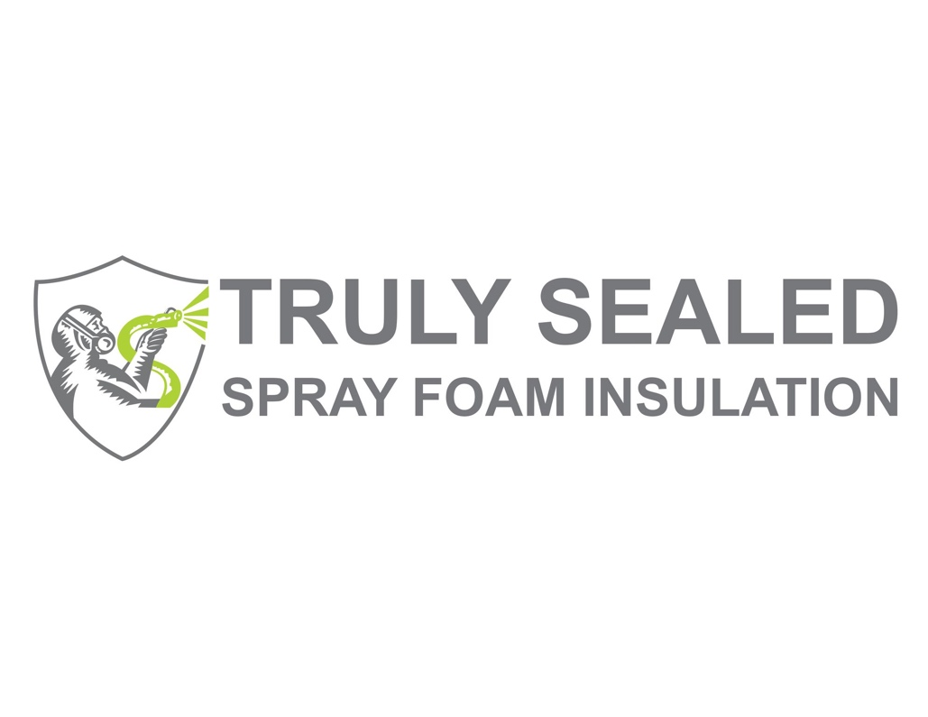
Lifetime Limited Warranty for Spray Foam Insulation
Issued by: Truly Sealed Insulation, LLC
Effective Date: [Insert Date]
Truly Sealed Insulation, LLC proudly offers this Lifetime Limited Warranty on spray foam insulation installed by our company, ensuring its performance and durability for the lifetime of the building in which it was installed.

Warranty Coverage
This warranty covers the following aspects of spray foam insulation installed by Truly Sealed Insulation:
- Thermal Performance: The spray foam insulation will maintain its thermal resistance (R-value) within normal, industry-accepted tolerances.
- Adherence and Integrity: The insulation will remain adhered to the applied surfaces and will not separate, delaminate, or deteriorate under normal conditions.
- Air Sealing Properties: The spray foam insulation will maintain its air sealing properties, reducing air infiltration when installed as part of an air barrier system.
Labor and Materials: This warranty covers both the cost of materials and labor required for any approved repair or reinstallation of the spray foam insulation.

Warranty Terms
This warranty is valid for the lifetime of the building, defined as the duration the original structure remains intact, from the date of installation.
Conditions of Warranty Coverage:
- This warranty applies only to spray foam insulation installed by Truly Sealed Insulation.
- The building must be properly maintained and in good condition.
- The insulation must not have been altered, tampered with, or damaged by subsequent renovations, repairs, or external forces.
- Any damage caused by acts of God, fire, flooding, pest infestations, structural failure, or other unforeseen events beyond our control is excluded.
Exclusions:
This warranty does not cover:
- Aesthetic changes such as discoloration or staining.
- Damage caused by improper installation not performed by Truly Sealed Insulation.
- Secondary damages resulting from insulation failure, such as mold or mildew growth caused by unrelated water intrusion.

Claim Process
To make a warranty claim, the property owner must:
- Notify Truly Sealed Insulation in writing within 30 days of discovering an issue covered by this warranty.
- Provide proof of purchase and documentation of installation.
- Allow us or our authorized representatives to inspect the site and determine the nature and scope of the issue.
If a valid claim is verified, Truly Sealed Insulation will, at our discretion, repair or reapply the spray foam insulation at no cost to the customer, including all labor and materials required.

Limitations of Liability
Truly Sealed Insulation's liability under this warranty is limited solely to the repair or reinstallation of the spray foam insulation. We are not liable for any incidental, consequential, or secondary damages related to insulation performance or failure.

Transferability
This warranty is transferable to subsequent owners of the building, provided that the insulation remains undisturbed, and all conditions outlined herein are met.

Contact Information:
Truly Sealed Insulation, LLC
1610 Oak Hollow Rd
Clermont, FL 34711
Phone: 833-777-2987
Email: trulysealed@gmail.com
Authorized Signature:

Ben Gregory
Owner, Truly Sealed Insulation

